附件
专家简介
1、张仲凯简介：张仲凯，二级研究员，博士，博士生/硕士生导师。云南省“云岭学者”，云南省中青年学术和技术带头人。国家自然科学基金委员会第十四届生命科学部植物保护学科组评审专家，香港浸会大学兼职研究员（University Fellowship），《植物学报》、《病毒学报》、《电子显微学报》编委。中国电子显微镜学会常务理事、农林专业委员会副主任委员，中国微生物学会理事，中国植物病理学会病毒学专业委员会副主任委员，中国农业生物技术学会理事，云南省电子显微镜学会理事长，云南省微生物学会副理事长。农业农村部西南作物基因资源与种质创制重点实验室副主任，云南省农业生物技术重点实验室主任，北京大学-云南省农业生物技术联合实验室副主任、秘书长。
现任低纬高原植物病毒研究与应用创新团队首席科学家，从事农业生物资源保护与利用，绿色有机农产品生产的病虫害绿色防控。侧重于植物病毒分类鉴定、病毒与寄主植物的分子细胞学互作机制、作物病毒病发生流行成灾机理与绿色防控技术研究与应用推广。主持承担国家自然科学基金7项（其中联合资助重点项目2项，地区重点项目1项）、“973”前期专项项目、“863”重点项目子课题、国家重点研发项目课题、云南省重大、重点项目等40多个项目。在PNAS，PLoS Pathogens，Scientific Reports等国内外学术刊物上发表相关研究论文200多篇，其中SCI收录80多篇，出版专著5部，获省部级科技成果奖10项，获国家发明专利29件。培养博士后、博士、硕士30多名。
Dr. Zhongkai Zhang: Professor, Principal investigator of the innovation group for low-latitude plateau plant virus research and application.
The group mainly focuses on the following aspects: 1. Protection and utilization of agriculture and bio-resources; 2. green prevention and control of the disease and pests during the production of green-organic agricultural products. Significant progress has been made in the identification and classification of plant viruses, decoding molecular interaction mechanism between virus and host plant, epidemic disaster mechanism of crop viral diseases, and research and promotion of disease and pests green prevention and control.
2、肖炜简介：肖炜，男，博士，副研究员，云南省“万人计划”青年拔尖人才，云南省科技特派员，昆明海关出入境特殊物品风险评估专家，云南大学“东陆中青年骨干教师”。现为云南大学云南省微生物研究所副所长。主要从事特殊生境微生物生态学研究，重点关注高盐环境和高原湖泊原核生物与噬菌体生态功能及其影响机制，噬菌体制剂的创制和应用。以第一或通讯作者在Science Of Total Environment，Developmental & Comparative Immunology，Virology，Viruses，Extremophiles等国际期刊上发表SCI论文20余篇。担任多个国内外期刊的特邀编辑和审稿人。获云南省自然科学二等奖1项。主持国家自然科学基金，中央引导地方科技发展专项，云南省重点研发计划（国际合作）等10余项，参编普通高等教育“十二五”规划建设教材等专著2部，获授权发明专利3项。
Xiao Wei, male, doctor, associate professor, Yunnan Province "Ten Thousand Talents Plan" youth top talent, Yunnan Province Science and Technology Commissioner, Kunming Customs entry and exit special items risk assessment expert, Yunnan University "Donglu young and middle-aged backbone teacher". Now he is the deputy director of Yunnan Institute of Microbiology, Yunnan University. His main research interests are microbial ecology in special habitats, focusing on the ecological functions and mechanisms of prokaryotes and phages in high-salinity environments and plateau lakes, as well as the development and application of phage preparations. First or corresponding author in The Science Of Total Environment, Developmental & Comparative Immunology, Virology, Viruses, Extremophiles and other international journals published more than 20 SCI papers. As guest editor and reviewer of many domestic and international journals. He won the second prize of Natural science in Yunnan province once. He has presided over more than 10 projects, including the NSEV, the Local Science and Technology Development Special Project under the guidance of the Central Government, and the Key Research and Development Program of Yunnan Province (international cooperation). He has participated in the compilation of 2 monographs, including teaching materials for the construction of the 12th Five-Year Plan of general higher education, and obtained 3 authorized invention patents.

3、刘莉简介：刘莉，教授，2003年毕业于华中农业大学生命科学系，2008年于同校获得遗传学博士学位，同年9月赴美国加州大学戴维斯分校从事博士后研究，2014年引进到中国科学院昆明植物研究所，并获得“百人计划”A类支持。2020年1月入职湖北大学生命科学院、省部共建生物催化与酶工程国家重点实验室，获得“杰出人才” 支持。长期从事植物抵抗非生物逆境研究，发掘在维持植物高光合效率条件下抗逆性遗传工程改良的基因和技术体系，解析植物非生物逆境的适应性进化与分子调控机制，共发表30余篇领域内有影响力的SCI论文，包括Plant Cell，Nature Communications, Plant Physiology等。申请中国专利18项和美国专利1项，8项已获得中国授权。
Name:LI LIU
Position: PI, Professor.
Organization: College of LifeSciences, HubeiUniversity
Address: 368 Youyi Rd. Wuchang, Wuhan, 430062Telephone: 86-15398712027
Email: liuli2020@hubu.edu.cn
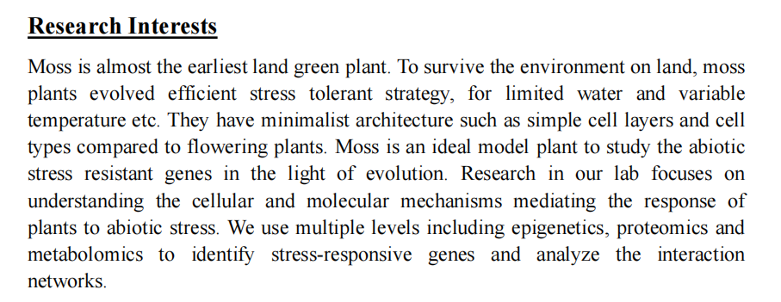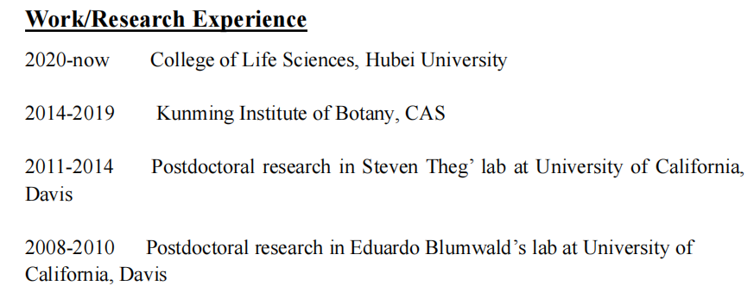
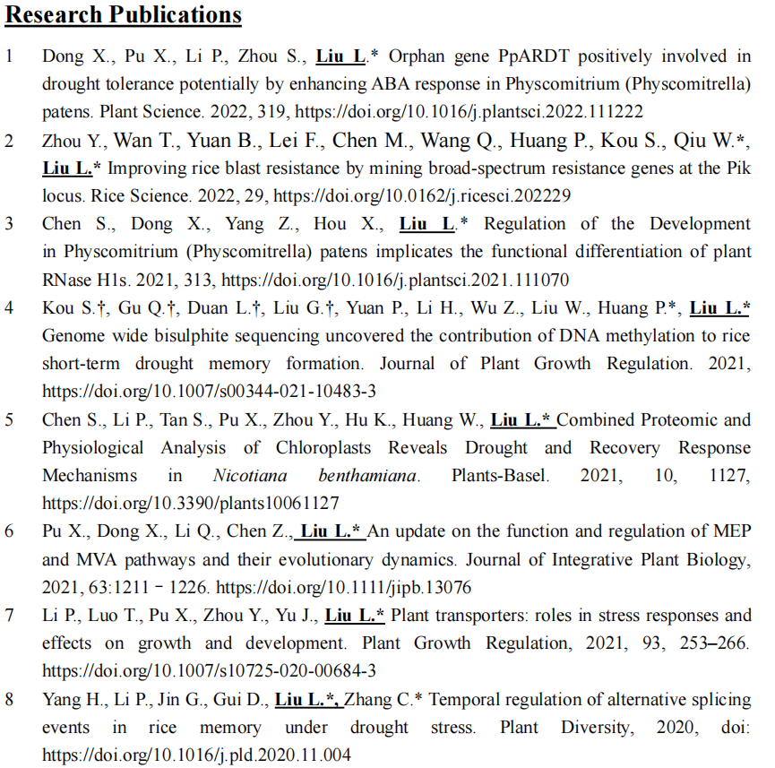
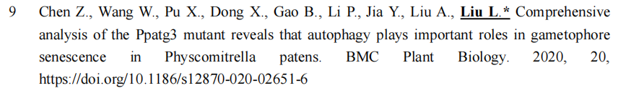
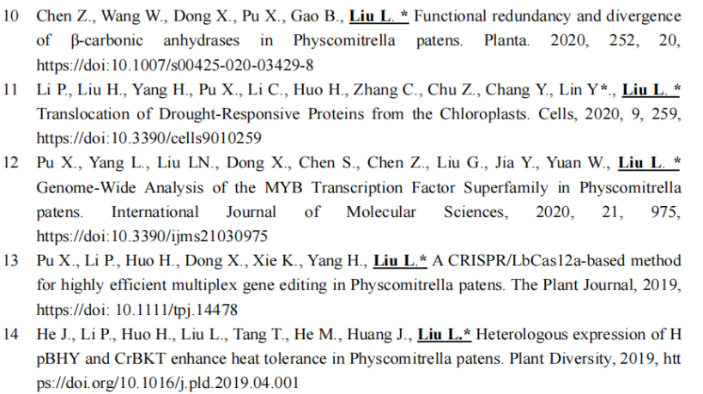
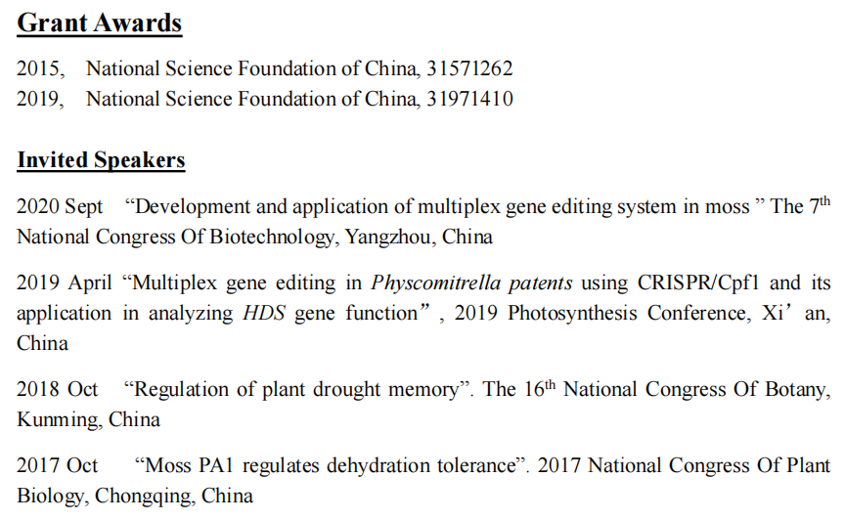

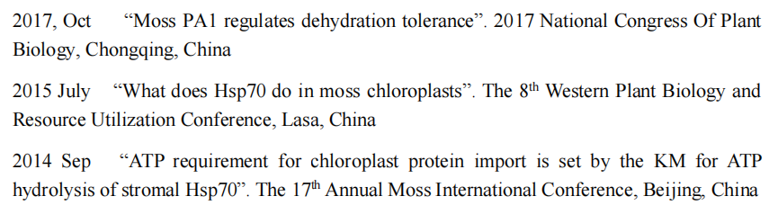
4、范江波简介：范江波，男，博士，现任上海交通大学农业与生物学院长聘教轨副教授、博士生导师、课题组组长。2011年11月，毕业于中国科学院大学，获得博士学位（硕博连读，培养单位为中国科学院遗传与发育生物学研究所）。2012年7月进入中国农业科学院植物保护研究所做博士后研究。2012年12月至2019年5月，在美国俄亥俄州立大学植物病理系做博士后研究。2019年9月入现职。长期从事植物抗病性和植物生殖生物学研究，在Cell Host & Microbe、Current Biology、Nature Communications等国际著名期刊发表论文13篇，担任英文期刊Molecular Horticulture编委，是多个著名期刊的审稿人。目前从事植物先天免疫系统研究，着重研究植物先天免疫反应的负调控机制。实验室以水稻为研究材料，运用多种手段，研究单子叶植物先天免疫负调控的机制及其在植物抗病和适应中的作用。主持上海市自然科学基金面上项目、上海市现代种业协同创新中心培育项目和上海交通大学 “农工交叉（Agri-X）”项目等3项。入选上海市“海外高层次人才引进计划”项目。
Jiangbo Fan, PhD, Associate Professor (PI) working at School of Agriculture and Biology, Shanghai Jiao Tong University (SJTU). Dr Fan got his PhD at University of Chinese Academy of Sciences (Institute of Genetics and Developmental Biology) in 2011. Then he worked as a postdoc in the Chinese Academy of Agricultural Sciences (Institute of Plant Protection) for 3 years (2012.8-2015.5). Dr Fan worked as a visiting scholar and postdoc in the Department of Plant Pathology, the Ohio State University, during 2012 to 2019. After postdoc research, he was appointed a group leader in the current institution. Dr Fan published 13 peer-review papers on leading journals including Cell Host & Microbe, Nature Communications, and Current Biology, etc. He is serving as an editorial board member of the journal of Molecular Horticulture and reviewing editor for multiple influential journals, including New Phytologist. His research is focusing on plant innate immunity, signaling and regulation, taking rice-blast as research model system. He is currently hosting 3 programs including those from Shanghai Natural Science Foundation, Shanghai Collaborative Innovation Center of Agri-Seeds, and SJTU (Agri-X). He is also supported by the Shanghai Oversea Talented program.

